Co-chair of board of trustees (ACT) 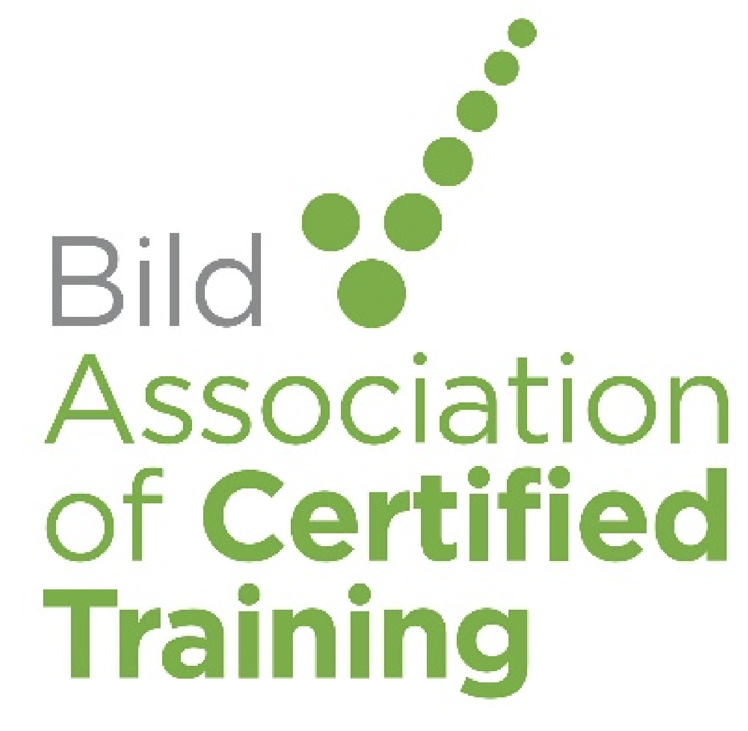

The role of the board of trustees is to:
- Make sure the charity’s activities are within the purposes (objects) of the charity and that they benefit the beneficiaries;
- Make sure the charity’s governing document, and law relevant to the charity, are followed;
- Act and make decisions in a way which is best for the charity’s purposes (objects);
- Manage the charity’s resources (money and other assets) responsibly.
- Use care when making decisions (e.g. preparing for and attending trustee meetings) and use other skills and experience where possible;
- Make sure the charity is accountable, for example by filing the accounts on time and informing members about what is happening at the charity.

Role description

The co-chair role provides shared leadership, governance, strategic guidance, and ambassadorial duties for the charity, with a specific emphasis on integrating the unique perspectives and insights of those who have experienced restraint. The role involves facilitating effective board meetings, fostering a diverse and inclusive board, and ensuring decisions reflect the needs of beneficiaries through constructive challenge.

Primary objectives (chair’s compass)

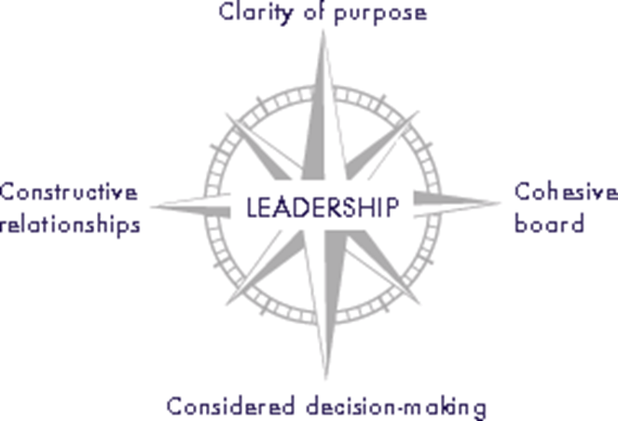
- The Co-chair works alongside the chair to provide leadership and direction to the Board of Trustees, enabling them to fulfil their responsibilities, ensuring their effectiveness and that the core values and purpose of the charity are met.

- S/he is responsible for the overall governance of the organisation and will work in partnership with the Chief Executive & Certification Director in the development of strategic direction (in accordance with the governing documents, legal and regulatory guidelines).

Main responsibilities

To ensure the Board functions effectively
- Chair meetings effectively to ensure agenda is covered efficiently and that different people’s views are heard and decisions are made democratically.
- Ensure that the board makes timely and unambiguous decisions about the issues referred to it.
- Work with the Chief Executive and Certification Director to ensure decisions taken at Board meetings are implemented

To ensure Trustees understand their responsibilities
- Ensure the charity has an appropriate governance structure that enables delegation of authority to sub-committees including Finance subcommittee and Bild group’s professional council and ambassadors with lived experience council (BFTF). As co-chair you will work in partnership with Bild for the future lived experience advisory group and ensure best practice in co-production throughout ACT.

To ensure the charity plans strategically
- Work closely with the Chair, Chief Executive and Certification Director to ensure there is clarity about the Charity’s vision, values and purpose at all levels of the organisation

To act as an ambassador spokesperson and advocate for BILD
- Work with the Chief Executive and Comms Director to represent the organisation at public events as required
- Exemplify the vision and values of the charity

Key Responsibilities
- Shared Governance:
Work with the chair and senior staff team to oversee the charity's governance and strategy
- Leadership & Facilitation:
Lead board meetings, chair discussions, and ensure all trustees are given necessary information to make informed, collective decisions.
- Strategic Guidance:
Guide the organisation's strategic direction and contribute to new ideas, particularly where you have relevant knowledge through lived experience.
- Beneficiary Focus:
Champion the needs of the our beneficiaries, ensuring the board's decisions and activities align with their perspectives.
- Board Development:
Help build and maintain an inclusive, diverse board that functions effectively and can address any gaps in knowledge or representation.
- Ambassadorial Duties:
Act as an ambassador for the charity, engaging with staff, trustees, stakeholders, and the public.
- Challenge & Accountability:
Foster a culture where different views are shared and constructively challenged, improving decision-making and avoiding groupthink.

Personal Qualities & Experience
- Lived Experience:
Direct personal lived experience of restraint (essential).
- People & Emotional Intelligence:
Possess excellent people skills, emotional intelligence, and the ability to make others feel comfortable to share their views.
- Communication & Collaboration:
Strong communication skills and the ability to work collaboratively in a team environment.
- Understanding of Governance:
Ability to understand the legal role and responsibilities of being a charity trustee.
- Strategic Thinking:
Ability to think strategically and contribute to the development of new ideas and future direction.
- Constructive Challenge:
Willingness to question assumptions, raise concerns, and participate in constructive disagreement.
- Broader Perspectives:
Bring broader perspective through lived experience providing diverse insights and experiences to the leadership, leading to more informed decision-making.

Responsibilities Compass & Person Specification

Area of chair’s compass | Core responsibility
Leadership | - Being willing and able to lead the organisation in partnership with the Chair, CEO and Certification Director
Clarity of purpose | - Ensuring the board discusses and agrees the purpose and core values of the organisation  - Ensuring decisions made advance the purpose and values of the organisation
Cohesive board | - Creating productive relationships with and among individual board members.  - Creating the environment for a high performing board team  - Ensuring board meetings are accessible, inclusive and understanding the needs of people with lived experience and the support they require
Constructive relationships | - Developing and maintaining productive working relationships with the Trustees, Chief Executive, Executive Leadership, Customers, Beneficiaries and other stakeholders
Considered decision- making | - Leading /steering the board in identifying the key governance decisions to be made  - Ensuring well founded and clear decision-making  - Able to evaluate and interpret information as well as think creatively  - Able to work through complex decisions and maintain focus on key issues  - Able to help groups achieve consensus when faced with contentious issues

 | Personal qualities and behaviours
Knowledge, skills and experience | Personal lived experience of restraint and significant experience of successful coproduction  Good understanding of education, health or social care sectors  Experience of working directly with people with lived experience of learning disabilities, autism, dementia or mental health conditions  Clear understanding of the distinction between governance and executive management and awareness of Trustee codes of conduct and good governance across the public and voluntary sector
Motivation and style | Altruism  Sense of humour  Empowering  Humble  Commitment to equal opportunities, inclusion and diversity  Committed to the ethos and values of the BILD group
Capacity to lead | Committed to the organisation  Devotes enough time to the organisation  Clear about the role  Capable of seeing the ‘big picture’  Capable of clarifying issues  Highly collaborative  Excellent communication skills and ability to communicate in plain English
Personal attributes | Integrity  Reflective/ listener Organised  Open /innovative
Ability to relate | Flexible  At ease with people of all types  Non judgemental  Calm

