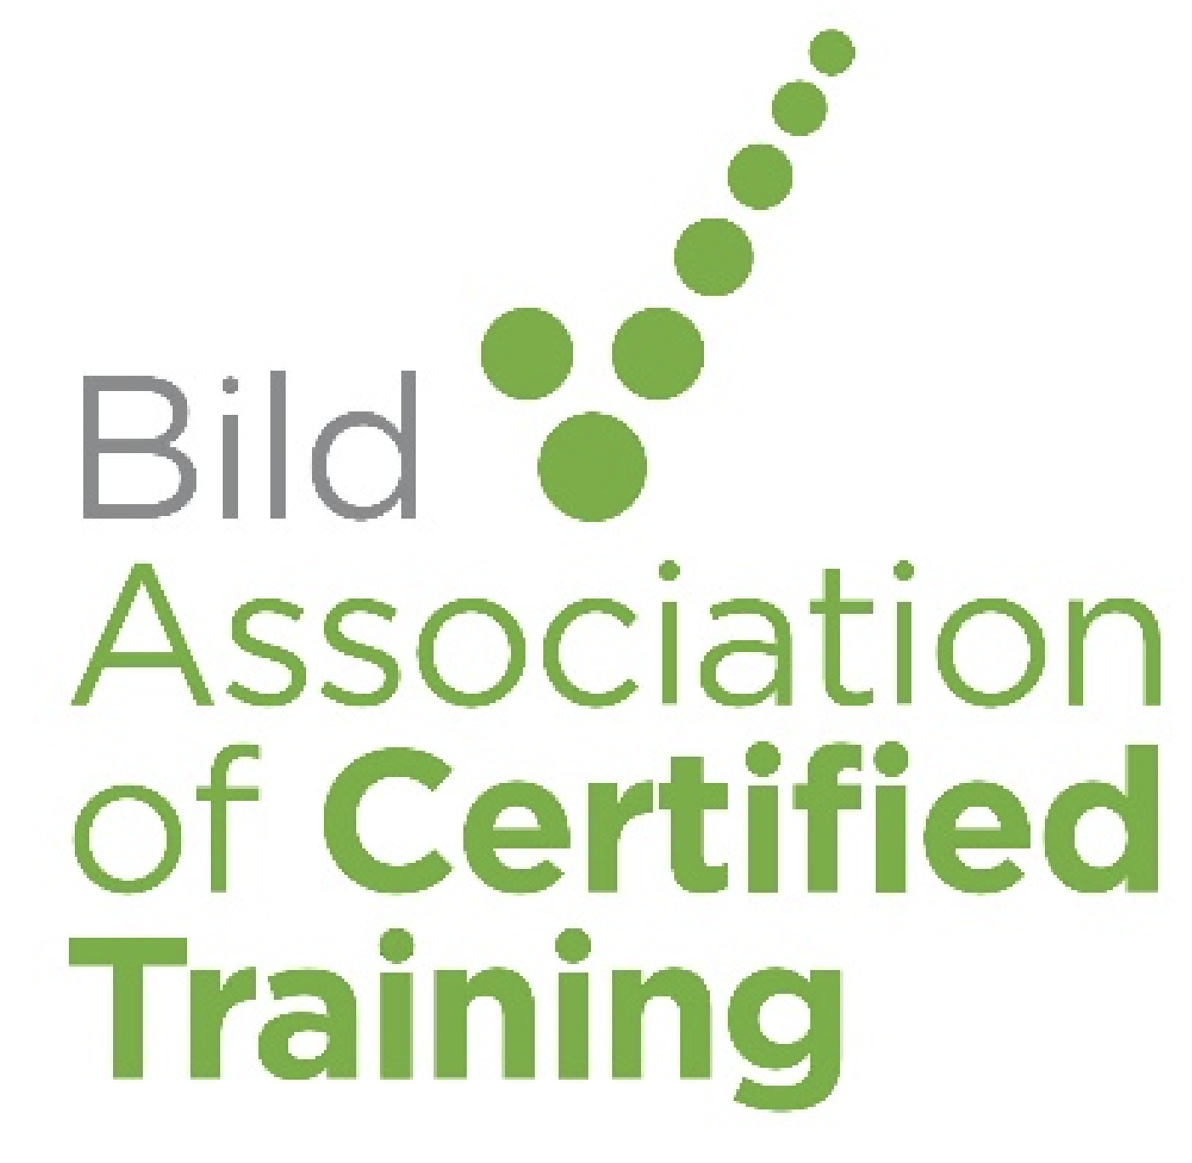

Co-chair of Board of Trustees for Bild Association of Certified Training (ACT) - Vacancy
Are you a person with lived experience of Restrictive interventions looking to make a real difference to a Charity certifying training organisations against the Restraint Reduction Network (RRN) Standards?
Bild ACT is looking for a dedicated and passionate individual to join our Board of Trustees as a Co-chair.
About the Bild ACT Co-chair role
This is an exciting opportunity to volunteer as a Co-chair for Bild ACT; a role that provides shared leadership, governance, strategic guidance, and ambassadorial duties for the charity, with a specific emphasis on integrating the unique perspectives and insights of those who have experienced restraint in a health, social care or education setting. The role involves co-facilitating effective board meetings, fostering a diverse and inclusive board, and ensuring decisions reflect the needs of its beneficiaries through thorough and constructive challenge.
With a committed and passionate Board of Trustees and a highly committed staff team already in place, you’ll join an organisation focused on making a positive difference to the provision of restrictive practice across all health, education and social care settings.
This is a voluntary role. Any expenses incurred while carrying out the duties of the role will be reimbursed.
About Bild ACT
Bild Association of Certified Training (ACT) is a UK charity providing certification for training that includes physical restraint.
ACT is licensed by the Restraint Reduction Network to certify training services as complying with the Restraint Reduction Network Training Standards. We improve the health and wellbeing of people accessing health, education, and social care services by assessing, certifying, and transforming the quality of training.
A Certification Body
ACT is a certification body, providing a certification service to training providers. ACT does not offer any training; we are solely a certification body.
Certification is an audit of whether a training service conforms to the criteria laid out in a recognised standard or scheme, in our case, the Restraint Reduction Network Training Standards
ACT's Credentials
ACT is proud to be the only UKAS accredited provider of certification against the ISO 17065, enabling us to certify services as complying with the RRN Training Standards. UKAS is the sole national accreditation body recognised by the British Government to assess organisations that provide certification services. ACT is subject to rigorous quality assurance processes to achieve and maintain our accreditation, undergoing quarterly internal audits, biannual vertical audits and annual external audit by UKAS.
ACT provides competent, qualified and experienced assessors, with our team undergoing ongoing continuing professional development.
ACT is licensed by the RRN to certify training as meeting the RRN Training Standards, and we are committed to upholding the integrity and spirit of the RRN.
If you share our vision, we would love to hear from you.
Further information
- View the full role description: https://bildact.org.uk/wp-content/uploads/2026/01/Co-Chair-Trustees-BILD-ACT-JD-2.docx
- Visit our website to find out more about Bild ACT: bildact.org.uk
- If you would like to arrange an informal discussion about the role, please contact. p.keedwell@bildact.org.uk
How to apply
To apply, please send your CV and covering letter outlining your experience and interest in the role to recruitment@bild.org.uk
Closing date for applications 31 January 2026.

