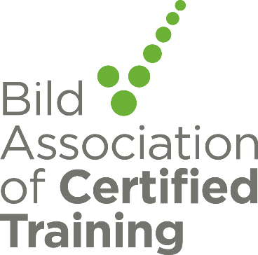

Bild Association of Certified Training Newsletter April 2021

Certification news
Statement Regarding 1st April Deadline
From the 1st April 2021 Providers of NHS commissioned services are required through the standard NHS contract to ensure that their training in restrictive practices has been certified as compliant with the Restraint Reduction Network standards. At this time, the Care Quality Commission will expect all regulated services across health and social care to only use training in restrictive practices that are certified as complying with the Restraint Reduction Network training standards.
Therefore, all approved training providers must only deliver training in restrictive practices that is certified as meeting the RRN Training Standards to these services (from April 2021).
Adjustments due to Covid
Due to the pandemic and exceptional circumstances temporary adjustments have been made to the requirements regarding refresher training and deadline for affiliate service providers to be approved.

Training providers can continue to temporarily deliver uncertified training to affiliates that require certified training (e.g. as NHS commissioned or CQC regulated) but have not yet been approved due to covid related delays provided they have a non-conformity action plan in place. The non-conformity action plans will need to be completed and affiliate approved by the start of July 2021.

This same date will apply to new training organisations working towards approval for certified training. This will mean after this date all training in these services will be certified.

It has been agreed that until 1st January 2022 reasonable adjustment are in place as some services are under extreme pressure to release staff for refresher training and service providers may therefore extend refresher training to up to 18 months (see previous guidance for more detail).

UKAS New Logo

UKAS have informed us that their logo is changing and a timescale for this change to be in place. Please read the attached carefully and include this information in your plans for changes to digital and hard documents. When we carry out our annual reviews, we will be checking use of logos on paper based and E information. View UKAS Brand information here

Find here the advice and guidance from Skills to Care
Guidance for employers, learning providers and in-house trainers on face-to-face training and assessment March 2021 update risk assessment guidance
Restraint Reduction Network News
Blended learning options survey
The RRN training standards focus on preventing the need for restraint wherever possible. Therefore, the standards required two days (12 hours) face to face training in preventative approaches as specified in standards 2.1- 2.15 prior to being taught physical skills techniques. The majority of these two days must be face to face (Standard 1.2.1).
Blended learning may be offered as an alternative or to complement to the ‘face to face’ training in preventative approaches.
Blended learning covers a wide range of methods and we would like to hear your views on the different approaches to blended learning delivery to inform a new appendix to the standards.
https://www.surveymonkey.co.uk/r/KQP3D2T

Questions about the Restraint Reduction Network Training Standards
If you have any queries about the Restraint Reduction Network Training Standards, please contact RRN@bild.org.uk and the Restraint Reduction Network will do their best to reply promptly. FAQs will be answered through this newsletter.

Best wishes
The Bild Association of Certified Training Management Team

