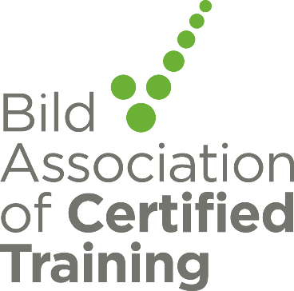

Bild Association of Certified Training Newsletter March 2021

Certification news
Change of Personal
This newsletter will be my last as Certification Manager as I’m retiring on the 26th March. Paul previously a Director of Nursing at a Mental Health Trust, becomes the new Director of Certification and joins BILD ACT on the 1st March. During his first busy month I’m sure he will meet with many of you and you will give him a warm welcome.
Scheme Handbook
BILD ACT has been revising the certification scheme handbook please note the changes which are listed at the front of version 6 Download here
UKAS New Logo

UKAS have informed us that their logo is changing and a timescale for this change to be in place. Please read the attached carefully and include this information in your plans for changes to digital and hard documents. When we carry out our annual reviews, we will be checking use of logos on paper based and E information. View UKAS Brand information here

Certified Organisations Meetings
Please note change to the next meeting date this will now be 18th March 2021 which is a change to the dates posted in the November newsletter this date is for all certified organisations invites will be sent out nearer the date.
Restraint Reduction Network News
Blended learning options survey

The RRN training standards focus on preventing the need for restraint wherever possible. Therefore, the standards required two days (12 hours) face to face training in preventative approaches as specified in standards 2.1- 2.15 prior to being taught physical skills techniques. The majority of these two days must be face to face (Standard 1.2.1).
Blended learning may be offered as an alternative or to complement to the ‘face to face’ training in preventative approaches.
Blended learning covers a wide range of methods and we would like to hear your views on the different approaches to blended learning delivery to inform a new appendix to the standards.
https://www.surveymonkey.co.uk/r/KQP3D2T

Questions about the Restraint Reduction Network Training Standards
If you have any queries about the Restraint Reduction Network Training Standards, please contact RRN@bild.org.uk and the Restraint Reduction Network will do their best to reply promptly. FAQs will be answered through this newsletter.

Best wishes
The Bild Association of Certified Training Management Team

